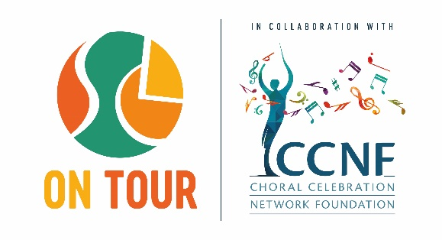

Application Form for the SCL ON TOUR South Africa  2026 (August 6th – 11th)

|  |  |
| --- | --- |
| **Official** **name** **and** **address** **of** **the** **ensemble** |  |
| Name: | Office phone: |
| Address: | Fax: |
| Website: | Email: |

|  |  |
| --- | --- |
| **Conductor** | **Chief** **Chaperone** |
| Name: | Name: |
| Mobile phone: | Mobile phone: |
| Home phone (optional): | Home phone (optional): |
| Email: | Email: |

|  |
| --- |
| **Number** **of** **travelling** **persons/** **age** **of** **performers** |
| Performers: Conductor: Non-performers (chaperons, etc.): |
| The performers are aged between and Average age: |

|  |  |
| --- | --- |
| **SCL ON TOUR PROGRAM** (Please select) | **Category** (Please select) |
| Competition  Celebration | Mixed Choirs  Symphony Orchestras  Treble Choirs  Chamber Orchestras with Winds  Male Choirs  String Orchestras  Children’s Choirs  Bands  Summa Ensembles |

By submitting the signed application form the signatory accepts the Terms and Conditions of the SCL Festival *(available* *for* *download* *on* *www.sclfestival.org)* as well as all decisions of the jury. The signatory represents the ensemble and ensures that the participants are aware of the Terms and Conditions set down by Via Musica.

Date

City

………………………………………………………….. Signature of the representative

**Please** **attach** **the** **required** **materials** **and** **forward** **to** **the** **artistic** **office:**

Concerts – Austria

Artistic office of the SCL Festival Columbus Reisen GmbH & CoKG Universitätsring 8, A-1010 Vienna, Austria

Email: [**office@sclfestival.org**](mailto:office@sclfestival.org)